CITY OF VIRGINIA BEACH, VIRGINIA

Infectious Disease (COVID-19)
Preparedness and Response Plan

OFFICE OF OCCUPATIONAL SAFETY AND HEALTH SERVICES
March 22, 2021
Updated from 2020 Original Document

Table of Contents

Organizational Policy and Compliance Statement

- Purpose
- Cooperative Partnership and Planning Guidance Development
- Responsibilities
- Determination of Exposure Risk by Job Duty
- Contingency Plans in the Event of an Infectious Disease Outbreak
- Basic Infectious Disease Prevention and Control Measures
  - Case Management and Medical Surveillance
  - Housekeeping
  - Cleaning/Disinfecting Substances
  - Employee Actions
  - Communications and Signage

- Identification and Isolation of Sick and/or Exposed Employees
  - Employee Self-Monitoring
  - Daily Screenings
  - Return-to-Work (RTW) Requirements

- Procedures for Minimizing Exposure from Outside of Workplace
  - Facilities/Assets

- Training
  - Attachment A Training Certification via Taleo LMS
  - Attachment B Training Certification for Contractors, Volunteers and others who work at City worksites

- Reporting and Notification Program
  - Attachment C Positive COVID-19 Test Reporting
  - Attachment D Positive COVID-19 Notification Document Page-1
  - Attachment E Positive COVID-19 Notification Document Page-2

- General Indoor Guidance
- General Outdoor Guidance

Annex A Hazard Assessment Form (Local departmental use – to provide to OSHS)
Annex B Work Hazard Assessment and Exposure Risk Level Assignment

Organization Policy and Compliance Statement
The Virginia Department of Labor and Industry (DOLI) at the direction of Virginia Governor Ralph Northam has developed and implemented the policies set forth in Virginia Code 16 VAC 25-220. This Standard for preventing the infectious disease SARS-CoV-2 (otherwise known as COVID-19) is designed to prevent the spread of COVID-19 and protect Virginia’s workers. The City of Virginia Beach is dedicated to ensuring that our personnel (full-time, part-time, temporary, and volunteer) are fully protected, remain healthy and can safely return to their families at the conclusion of their work. This COVID-19 focused preparedness and response plan sets forth the measures, policies, assessments, and enforcement measures that the City of Virginia Beach will utilize to ensure the best possible working environment. Employees failing to abide by the requirements of this health and safety direction will be subject to disciplinary action in accordance with our City Discipline Policy and Procedure 4.02

Should you have any questions please contact your supervisor or manager about local department compliance efforts, or Occupational Safety and Health Services (OSHS) to address any health or safety questions or concerns that you may have about the City’s planning, preparedness, and response to the COVID-19 pandemic.

I. Purpose
The purpose of this plan is to provide for a safe, healthy and secure environment for our workforce to work and where residents receive core municipal government services. The Plan describes the implementation of mandatory health and safety requirements established by the Virginia Department of Labor and Industry (DOLI), Governor Northam’s COVID-19 Executive Actions and Executive Order(s) and subsequent Addendum(s) as well as voluntary guidance issued from the Centers for Disease Control (CDC) – and adopted by the City.

II. Cooperative Partnership and Planning Guidance Development
This plan shares references with the City of Virginia Beach COVID-19 Operational Planning Guidance developed by the Office of Emergency Management (OEM).
This plan was initially created with input from all City departments and offices, and discussion with our contract labor/temporary workforce partners, and the Virginia Department of Health. Following initial development, our entire workforce and partners will continue to have opportunity to provide feedback and input for plan revision and improvements by the following methods available via our Beachnet OSHS Website for COVID-19 Guidance:
- Hazard Assessment Form
- eMail to safety@vbgov.com

III. Responsibilities
The City of Virginia Beach has assigned the following individual(s) to serve in the role of health and safety officer. The health and safety officer has the authority to stop or alter City activities to ensure that all work practices are performed in a safe manner and also conform to the mandatory safety and health requirements applicable to COVID-19 as well as any other infectious disease hazards.
The following table lists OSHS staff delegated as City Health and Safety Officers:
Health and Safety Officer(s)
Name | Role/Title | Organization | Phone Number
Scott Kalis | Chief Safety and Health Officer | Occupational Safety & Health Services (OSHS) | (757) 385-8423
Judy Weiss | Safety Supervisor - Designated Health and Safety Officer | Occupational Safety & Health Services (OSHS) | (757) 385-8859
Amanda Martin | Safety Engineer - Designated Health and Safety Officer | Occupational Safety & Health Services (OSHS) | (757) 385-8433
Michael Rexroad | Safety Engineer - Designated Health and Safety Officer | Occupational Safety & Health Services (OSHS) | (757) 385-8559
Michele Borden | Nursing Supervisor - Designated Health and Safety Officer | Occupational Safety & Health Services (OSHS) | (757) 385-8876

For the purpose of ensuring compliance with the most current state and federal safety and health requirements, Scott Kalis, Occupational Safety and Health Services Manager has been identified as the City’s Chief Safety and Health Officer and is responsible for administering this plan, monitoring partner and regulatory agencies for new requirements, updating this plan, communicating appropriate content changes to employees, and monitoring the overall effectiveness of the plan. This person is also responsible for providing employees with a copy of this plan upon request.
A current copy of this Infectious Disease Preparedness and Response Plan will be posted to Beachnet on the OSHS Website and under COVID-19 Guidance. This Plan will be updated by OSHS when/as necessary.
IV. Determination of Exposure Risk by Job Duty
Through careful assessment of our very diverse and dynamic work activities and with opportunity for input from all City departments and offices, we have determined the COVID-19 exposure risk level of our physical worksite functions and our field activities to ensure that we apply appropriate hazard controls. These include workforce and contractor training, equipment needs, administrative guidance and enhanced safe work practices, and personal protective equipment (PPE) or other protective resources. This assessment was based on OSHA Publication 3990 and VOSH/DOLI 16VAC25-220 and undertaken to protect our personnel’s safety and health. Employee groups or types have been assigned to defined risk exposure categories as follows:
“Very High” exposure risk hazards or job tasks are those in places of employment with high potential for employee exposure to known or suspected sources of the SARSCoV-2 virus and the COVID-19 disease including, but not limited to, during specific medical, postmortem, or laboratory procedures.
“High” exposure risk hazards or job tasks are those in places of employment with high potential for employee exposure within six feet with known or suspected sources of SARS-CoV-2 that are not otherwise classified as “very high” exposure risk.
“Medium” exposure risk hazards or job tasks that are not labeled as “very high” or “high” in places of employment that require more than minimal occupational contact inside six feet with other employees, other persons, or the general public who may be infected with SARS-CoV-2, but who are not known or suspected to be infected with the SARS-C0V-2 virus.
“Lower” exposure risk hazards or job tasks are those not otherwise classified as “very high”, “high”, or “medium” exposure risk that do not require contact within six feet of persons known to be, or suspected of being, or who may be infected with SARS-CoV-2; nor contact within six feet with other employees, other persons, or the general public except as otherwise provided in this definition (refer to Virginia Code 16 VAC 25-220, for a more detailed description).
Exposure Risk Level means an assessment of the possibility that an employee could be exposed to the hazards associated with SARS-CoV-2 virus and the COVID-19 disease. Hazards and job tasks have been divided into four risk exposure levels: “Very High”, “High”, “Medium”, and “Lower”.
This illustration below relates to job tasks that pose a risk level to employees. The job tasks that are listed are not an all-inclusive list, but provide a general view of where, how, and what sources of SARS-CoV-2/COVID-19 might employees be exposed to at work.
Employees Not Exposed Within 6 Feet Frequently or Close Contact with Persons Known, Unknown, or Suspected of COVID-19. Have Minimal or No Contact with Public, Coworkers, or Other Persons.
Employees Exposed Within 6 Feet of Other Employees, Customers, or Other Persons Known, Unknown, or Suspected of COVID-19.
Healthcare Delivery & Support, First Responders, Medical Transport, Mortuary Employees, Employees Exposed Within 6 Feet of Known or Suspected COVID-19. This includes first responders.
Healthcare Employees, Performing Aerosol-Generating Procedures, Healthcare/Lab Personnel, Morgue Employees, Known or Suspected COVID-19 Patients. Personnel collecting COVID-19 specimens.
Occupational Safety and Health Services references the definition of “Exposure Risk Level” of the Final Permanent Standard for Infectious Disease Prevention of the SARS-CoV-2 Virus That CausesCOVID-19 by the Virginia Department of Labor and Industry, and also pages 18 - 20 of the OSHA document “Guidance on Preparing Workplaces for COVID-19” which is useful in determining the risk level of each employee or class/group of employee based on their type of work and their occupational general duties. Some jobs may have more than one type of exposure risk depending on the task or unique qualifying factors. For this reason, our approach to training will be to train all employees across the City in both Low or Medium risk categories to the level of Medium Exposure Risk Level, similar to High and Very-High categories.
We have worked to determine the exposure risk levels of all our personnel using a standard template (Annex A - “Hazard Assessment Form”), from which we then created an overarching matrix of job categories, classes or groups listing the work area or job category, the job/occupational tasks, employee exposure risk, and qualifying factors in the matrix at the end of this document (Annex B - “Work Hazard Assessment and Exposure Risk Level Determination”).

V. Contingency Plans in the Event of an Infectious Disease Outbreak
In the event that an outbreak or pandemic due to an infectious disease, the City of Virginia Beach has established contingency plans for addressing the workplace needs as well as employee safety and health during the outbreak. These contingency plans evolve and are revised base upon updated information from regulatory agencies, and medical and clinical guidance. The approach of Occupational Safety and Health Services is to follow medical recommendations and scientific standards for protecting our personnel, our property, and the environment. We also work with our partners in OEM and public safety.
City departments develop local operating plans for their staff to follow in response to modified operations at their worksites, and these plans shall be reviewed by both OEM and OSHS before being activated. From initial planning to ongoing revision and updating, all departments follow the protocols set forth by OSHS and OEM for workforce preparedness and response to impacts to critical or essential operations and continuity of government.
For contingency planning, these documents and references include:
OEM COVID-19 OPERATIONAL PLANNING GUIDANCE
Flexible Workplace Policy 2.04
Public Health Emergency Operations and Leave Policy 3.16
Discipline Policy and Procedure 4.02
Municipal Operations and Staffing Policy 6.03
Municipal Facilities Closure Policy 6.09

VI. Basic Infectious Disease Prevention and Control Measures
To control the spread of infectious diseases such as COVID 19, The City of Virginia Beach has implemented basic prevention and control measures to ensure that all personnel are protected against the hazards of infectious disease. These include the following;
- Case Management and Medical Surveillance
OSHS manages reported suspect cases, confirmed cases, and works with VDH and VOSH to conduct medical surveillance and testing at subject worksites or workgroups when indicated by emerging positive case rates, or a defined outbreak.
- Housekeeping
It is important to maintain routine/general housekeeping in the workplace. Additional (or enhanced) housekeeping actions must also be implemented to ensure the safety and health of employees and further decrease the chances of spread of an infectious disease All restrooms, common areas that remain in use, door knobs/handles, tools, equipment, and other frequently touched surfaces are disinfected (at least) before, in the middle of, and at the end of each shift. Many work locations require more frequent cleaning of surfaces. All contact surfaces of vehicles used by more than one person shall be disinfected at the end of each person’s use. All disinfectants must be approved and comply with CDC disinfection guidance. Disinfecting can be achieved utilizing substances approved for use against SARS-CoV-2 virus, and sourced from the EPA’s List-N, or non-EPA-registered disinfectants approved by OSHS and provided by the City, if they otherwise meet the EPA criteria for use against SARS-CoV-2 virus, to kill germs on surfaces. Contact Building Maintenance – Custodial Services and/or OSHS for specific guidance on approved substances and procedures.
Updated
03/22/2021
- Cleaning/Disinfecting Solutions
Chemical manufacturer’s Safety Data Sheets (SDS’s) are available to all workforce on the chemical substances approved for use, and all affected employees using cleaning and disinfecting products must receive basic chemical hazard communication (HazCom) awareness training which can be accomplished by online instruction or in-person (just-in-time) methods. Visit the City’s Chemical Inventory Management System or check with local storeroom or supervisors for SDS information.
Occupational Safety and Health Services has created several training videos (including one on basic chemical safety) for employees that can be accessed on Beachnet on the OSHS Website: https://beachnet.vbgov.com/members/covid-19-guidance
- Employee Actions
Additional basic precautions and actions that the City of Virginia Beach is taking:
- All employees are required to conduct a daily self-screening prior to coming to worksites or client locations, and report any illness to their supervisors.
- Large workforce and public gatherings are minimized whenever possible; staff meetings are postponed, cancelled or held remotely;
- Employees are required to maintain physical distance even when on break, as well as before and after working hours if on City property;
- Employees are required to maintain physical distance when reporting to work or leaving work in halls, entrances/exits and potential choke-points in buildings;
- Employee work stations are arranged to be greater than six feet apart or engineering solutions are installed providing appropriate safety separation and protection (approved by Building Maintenance and OSHS);
- Utilize flexible work hours, wherever possible, to limit the number of employees simultaneously working on-site;
- Employee interactions with the general public are modified to allow for additional physical space or barriers between affected parties.

- Communications and Signage
Departments are responsible for ensuring appropriate communications are made with their workforce members and the public that they may interact with. Internal communications that spans the entire City workforce will be coordinated through Human Resources. Internal and external signage for COVID-19 are coordinated through the City’s Communications Office. Departments should ensure updated signage is posted as new guidance is released and adhere to the Forward Virginia guidelines.
As departments modify operations based on the current COVID-19 environment, they must notify the Communications Office of the changes and coordinate news releases with them, unless a different agreement has already been reached and documented with the department. All relevant information about City facility re-openings and resumption of services will be posted on the VB COVID-19 Emergency page, and departments should work with the Communications Office to ensure the latest updates are reflected on this website.
COVID-19 facility signage is required in many situations, as outlined below. Signage will include signs and symptoms of the virus, physical distancing requirements, cleaning and disinfecting practices, hand washing, wearing a face mask/covering, etc.
Updated
03/22/2021
Internal Facility Signage
Internal signage should be posted in employee workspaces and employee-facing areas.
Required:
- CVB COVID Occupancy Poster (required in common areas, breakrooms, meeting or conference rooms, locker rooms, etc.)
- Post signage at the entrance of all indoor areas stating that employee and patrons must wear a mask/cloth face covering in accordance with Commonwealth of Virginia Executive Order 72 in addition to previous Executive Orders which remain in force.
- Post signs and share communications about the importance of reducing the spread of COVID-19 by practicing personal hygiene, physical distancing and use of protective resources, including For Your Safety sign, as referenced on the Beachnet COVID-19 Information page.
- Post signage telling employees not to come to work when sick.
Recommended:
- Post signs and share communications about the importance of personal hygiene, physical distancing and protective resources, as referenced on the Beachnet COVID-19 Information page.
- Where applicable, install visible markers for queue lines that separate people by six feet of physical distance. Provide physical guides to seating areas including floor decals, colored tape, or signs to indicate where attendees should not sit, stand, or congregate. Refer to the general Beachnet COVID-19 Information page.
Updated
03/22/2021
External Facility Signage
External signage should be posted at building entrances, lobbies, and customer service areas.
Required:
- Post signage at the entrance of all public areas stating that employee and patrons must wear a mask/cloth face covering in accordance with Commonwealth of Virginia Executive Order 72 in addition to previous Executive Orders which remain in force
- Post signage to provide public health reminders regarding physical distancing, options for high-risk individuals, and staying home if sick, including For Your Safety sign.
Recommended:
- Post signs and share communications about the importance of personal hygiene, physical distancing and protective resources. Refer to the general Beachnet COVID-19 Information page.
- Post signage at the entrance that states that no one with a fever or symptoms of COVID-19, if they have a positive diagnostic test for the virus that causes COVID-19, or known exposure to a COVID-19 case in the prior 14 days, is permitted in the worksite.

VII. Identification and Isolation of Sick and/or Exposed Employees
Risk and exposure determinations are made without regard to employees protected characteristics as defined by local, state, and federal law.
Any health-related information and documentation gathered from employees is maintained confidentially and in compliance with state and federal law. Specifically, medical documentation is stored separate from employee’s personnel documentation and maintained in OSHS in strict accordance with both HIPAA and ADA regulations.
- Employee Self-Monitoring
The following employees should not report to work and, upon notification to The City of Virginia Beach; will be removed from the regular work schedule until cleared to return:
- Employees who display COVID-19 signs & symptoms, such as fever, new onset or unexplained headache, cough, shortness of breath, sore throat, congestion or runny nose, new loss of smell or taste, and/or gastrointestinal problems, including nausea, diarrhea, and vomiting, confusion, chills, fatigue, muscle or body aches, bluish lips or face (which is an emergency situation) whether or not accompanied by a formal COVID-19 diagnosis;
- Employees who have not been fully vaccinated more than 14 days prior, have had close contact with and/or live with any person having a confirmed COVID-19 diagnosis: or
- Employees who, in the last 14 days and who have not been fully vaccinated more than 14 days prior, have had close contact with and/or live with any person displaying COVID-19 signs & symptoms listed above.
Unvaccinated employees may only resume in-person work upon meeting all return-to-work (RTW) requirements detailed in the CVB Public Health Emergency Operations and Leave Policy 3.16, as indicated by OSHS following current CDC guidance, or in consultation and by clearance with the Virginia Department of Health. Due to the nature of this novel Virus, standards for clinical assessment, treatment, and care, and returning healthy persons safely to work evolve, situations may dictate additional requirements required by OSHS or the Virginia Department of Health.
Updated
03/22/2021
- Daily Screenings
To prevent the spread of COVID-19 and reduce the potential risk of exposure, The City of Virginia Beach requires employees to self-screen each workday prior to coming to a worksite or client location. Some employees are required to conduct this screening more than once per day based upon institutional or other agency requirements. In these instances, local guidance will be provided.
Generally – across the City, the taking of temperatures at work is not authorized or recommended unless required by a specific agency (such as The Department of Social Services), and a documented plan has been approved by OSHS prior to implementation.
If a thermometer is available, and an activity has been approved to perform such by OSHS, temperature checks may be performed. (e.g., out of school care programs, etc)

Workforce Members
Departments should integrate the following guidance for workforce members into their COVID-19 Operational Plan and ensure departmental processes reflect implementation of this guidance:
- Workforce members with an Active Directory account should perform self-health screening before entering the facility. Career staff can perform self-health screening by logging into the City of VB Health Screening app to complete the COVID-19 Health Screening. Others not able to access the City Health Screening tool should work with their respective leadership to utilize an alternative means of ensuring daily completion of a self-screening for COVID-19 prior to coming to a workplace or client location.

- Employee exposures should be reported as indicated through the COVID Exposure Reporting Flowchart and Notification Forms posted on the general Beachnet COVID-19 Information Page.

- Practice physical distancing of at least 6 feet during general operations or 10 feet during exercise/vigorous activity. Facial masks/coverings are required when 6-foot physical distancing cannot occur, as referenced in the CVB Public Health Emergency Operations and Leave Policy 3.16.

- Stay in assigned work/gathering areas as much as possible and only travel throughout the worksite when absolutely necessary. When leaving the work/gathering area, wear a face mask/covering.

- When in-person meetings need to occur, keep meetings as short as possible, limit the number of employees in attendance, and use physical distancing practices.

- Continue to coordinate teleworking and rotating/staggering work shifts/gatherings.

- Departments are responsible for procurement and ensuring proper utilization of Personal Protective Equipment (PPE) and other simple protective resources for workforce members.

- City Employees shall complete the COVID-19 Mandatory Training located in the Taleo Learning Management System (LMS), or approved alternative methods. This training consists of a COVID-19 Safety Training course, and briefing on this Infectious Disease Preparedness and Response Plan. Additional recommended training videos, including proper use of PPE, conservation of PPE, and use of chemicals for cleaning/disinfecting, are available on Beachnet on the OSHS site.

- New members will be provided access to mandatory health and safety training during the City’s New Member Orientation program, and departments should consider including additional COVID-19 training in their new employee onboarding processes.
Updated
03/22/2021

- Human Resources will continue to support and work with departments on individual teleworking accommodations and shift schedules.
Volunteers
Departments should plan for how to engage and reintegrate volunteers into the workforce during COVID-19. There is no “one size fits all” approach across departments and volunteer programs; however, the Office of Volunteer Resources created a COVID-19 Volunteer Reintegration Guide that serves as a useful reference.
Key guidance includes:
- COVID-19 Self Checks for Volunteers: All volunteers should conduct a self-check prior to going to work, and if ill or experiencing any of the common symptoms for COVID-19, call their supervisor to report such and not report to work.
- Mandatory COVID-19 Safety Training: Current and future volunteers should take the mandatory COVID-19 Safety Training by following the guidance below:
a. Ask them to watch the COVID-19 Training on YouTube. (We recommend including this video to onboarding process for new or returning volunteers.)
b. Then, track this training (in both places) on Volgistics so they can send reports to OSHS:
i. Hours of service - Whether they watch it at a worksite or on their own, this time will be captured as 30 minutes of volunteer time under their normal assignment (please do not create an assignment for training)
ii. As training is completed on the History Tab - The "class" event notation has been added in Volgistics for "COVID-19 Safety Training" which can be added on individual's history tab or for several tagged records from the "Tags" tab.
If there are any questions regarding volunteer engagement during COVID-19, please reach out to Volunteer Resources at volunteer@vbgov.com
A basic reference chart of the daily screening questions is illustrated below. For most up-to-date information or policy, refer to PHE Policy 3.16 or follow guidance of your provider.
This information is reference for unvaccinated individuals.

Personnel who develop signs & symptoms for COVID-19 during their shift must immediately contact their supervisor and leave the workplace. The supervisor will then notify their department, and OSHS for further guidance and direction, to include assessing workplace impact to other staff, the physical location itself and/or other parties such as customers, clients, and citizens.

Updated
03/22/2021
Updated
03/22/2021
- Return-to-Work (RTW) Requirements
The City of Virginia Beach has implemented a CVB Public Health Emergency Operations and Leave Policy 3.16.
Sick employees are required to stay home, and not come into the workplace.
Policies and posters are placarded in common places as well as on the employee Beachnet internal web portal. If employees have questions regarding use of emergency paid sick time, employees should contact their department HR liaison and/or PALs.
- The City of Virginia Beach will follow state and federal guidance for returning employees to work.
  - Guidance from employee’s health care providers will also be considered and evaluated by OSHS.
Employees who were themselves diagnosed with COVID-19 may only return to work upon confirmation of the cessation of symptoms and contagiousness, and by following the symptom-based strategy or another protocol that their attending provider/clinician (a MD, DO, NP or PA) has prescribed as the best method for that individual.
The City Public Health Emergency Operations and Leave Policy 3.16 will be the standard used for this process, but for general guidance from the CDC on When You Can be Around Others (or Return to Work):
- A symptom-based strategy following current CDC guidance - employees who have an uncomplicated case may discontinue isolation and return to work upon achieving the following conditions:
- 10 days since symptoms first appeared and
- 24 hours with no fever without the use of fever-reducing medications and
- Other symptoms of COVID-19 are improving*
*Loss of taste and smell may persist for weeks or months after recovery and need not delay the end of isolation​
Updated
03/22/2021
Most people do not require testing to decide when they can be around others; however, if your healthcare provider recommends testing, they will let you know when you can resume being around others based on your test results.
Note that these recommendations do not apply to persons with severe COVID-19 or with severely weakened immune systems (immunocompromised). These persons should follow the guidance below for “I was severely ill with COVID-19 or have a severely weakened immune system (immunocompromised) due to a health condition or medication. When can I be around others?”
Reference: https://www.cdc.gov/coronavirus/2019-ncov/if-you-are-sick/end-home-isolation.html

For Employees Who Has Been Around a Person with COVID-19 and has been fully vaccinated:
Anyone who has been fully vaccinated, and who has had close contact with someone with COVID-19 does not need to quarantine for 14 days after exposure to that person.
NOTE: As of March 9th 2021 the CDC published interim guidance for “When You’ve Been Fully Vaccinated”. People are considered fully vaccinated:
2 weeks after their second dose in a 2-dose series (like the Pfizer or Moderna vaccines), or
2 weeks after a single-dose vaccine (like Johnson & Johnson’s Janssen vaccine)

If it has been less than 2 weeks since your shot, or if you still need to get your second dose, you are NOT fully protected. Keep taking all prevention steps until you are fully vaccinated. This includes quarantining.

For Employees Who Has Been Around a Person with COVID-19 and have not been vaccinated:
Anyone who has not been fully vaccinated, and who has had close contact with someone with COVID-19 should stay home for 14 days after their last exposure to that person, and contact their provider/clinician for medical clearance to return to work. This is the standard quarantine recommendation from the CDC and what the City of Virginia Beach follows for our case management.
NOTE: As of December 3rd 2020 the CDC and VDH have provided “options” for a 7-day or a 10-day alternative quarantine period with accompanying COVID19 testing and direct clinical case management. These cases for exception may be addressed on a case-by-case basis by OSHS in consult with the Department of Health and/or an employee’s provider.
Updated
03/22/2021
If an employee is contacted by VDH to self-isolate or quarantine and remain home in contact with them for the process of contact-tracing and follow up, employees should request a written clearance from VDH to return to work when eligible.
Employees who wish to return to work following a complicated COVID-19 case, should submit to OSHS a medical clearance or release to Return to Work from their healthcare provider. (i.e., MD, DO, NP or PA). These “complicated cases” are those which involved medical treatment, hospitalization, or clinical interventions. Uncomplicated cases are those which typically self-resolve and do not require clinical care, medical treatment of hospitalization.

VIII. Procedures for Minimizing Exposure from Outside of Workplace
The City of Virginia Beach operational practices are evaluated to ensure the safety and health of all individuals. This is done on a phased approach. Beginning with appointment-only onsite meetings, use of virtual meetings, and finally transitioning to onsite meetings with appropriate precautions when that time comes or when necessary for work teams.
Any individual entering a City of Virginia Beach facility may have their temperature checked and/or be asked screening questions prior to allowing entry.
- Generally – across the City, the taking of temperatures at work is not authorized or recommended unless required by a specific agency (such as The Department of Social Services), and the program and documented plan have been approved by OSHS prior to use.
All individuals required under the Governor’s Executive Orders, or by public health emergency requirement shall wear an appropriate cloth face covering or simple mask that completely covers their mouth and nose, and is of material suitable for source control (protective) measures, i.e., cannot be made of mesh or knitted type material with holes rendering it ineffective. If they are medically unable to do so, they are required to wear a plastic face shield that completely covers their face from side to side and down to their chin. This face shield must be worn properly and effectively when in use.
Updated
03/22/2021
For reference, see section VI. Basic Infectious Disease Prevention and Control Measures in this Plan, and refer to Communications and Signage which describes external signage requirements and methods of communicating to the public entering our worksites.
To further minimize exposure from visitors or vendors:
- Business partners that work within the City of Virginia Beach facilities/worksites will be provided this Plan. (i.e., Contract/Temporary Labor Workforce Agencies.)
- The City of Virginia Beach will actively limit the number of visitors in their facilities and work sites, and monitor for compliance with established occupancy limits, and post required signage to alert personnel.
- Masks may be available to visitors/vendors as well as appropriate disinfectants so individuals can clean work areas before and after use.
- Deliveries will be handled through curbside pick-up/drop off or scheduled delivery and precautions taken to minimize exposure potential.
Minimizing exposure from the general public:
- Social/Physical distancing practices to be observed:
- 6-foot distances are marked in areas where individuals might gather/wait.
- Limit number of individuals allowed into the workplace and post required signage to alert personnel.
- Minimize face to face contact:
- Workstations positioned at least 6 feet apart and/or separated by physical engineering controls approved by Building Maintenance and OSHS.
- Information is posted in City of Virginia Beach facilities educating individuals on ways to reduce the spread of COVID-19 and available on Beachnet.
- In accordance with Final Permanent Standard for COVID-19 by the Virginia Department of Labor and Industry, individuals with clearly visible COVIID-19 signs or symptoms will be removed from the workplace to protect the workforce.

- Facilities/Assets
- Departments should follow the most current City Cleaning and Disinfection Plan, posted on BeachNet. The plan outlines routine and enhanced cleaning measures for all City facilities (also includes references for specific facilities) and confirmed positive COVID-19 cleaning protocols.
- Adjust facility capacity limits to account for distancing and specific functions taking place, considering the most current Virginia Safer at Home: Phase Guidelines. If you have questions or need consultation about capacity and /or engineering controls in your facilities, please reach out to Occupational Safety and Health Services at safety@vbgov.com
- Reduce occupancy in facility internal spaces such as conference rooms, gathering areas, breakrooms, kitchens, etc. to ensure 6 feet of distance is maintained between employees while in these spaces. Post the CVB COVID Occupancy Poster in these spaces to inform employees of space limitations and other responsibilities.
- If barriers or sneeze guards are needed to protect members in a public-facing setting or areas where social distancing cannot be maintained, please coordinate with Public Works – Building Maintenance at 385-4561 or pwbldmnt@vbgov.com
- Section off areas of the facility not being used.
- Signage and infographics will be posted at the facility for both internal workforce members and public members visiting (if applicable). Departments that work in shared buildings must work with other departmental POCs in their building to coordinate placement of signage and adherence to City guidance (as listed above) in public or common areas. Please see the Communications and Signage section for additional information.
- Regularly clean and disinfect public spaces and high touch surfaces (door knobs, light switches, rails, etc.) following CDC Guidance for Cleaning and Disinfection.
Disinfecting can be achieved utilizing substances approved for use against SARS-CoV-2 virus, and sourced from the EPA’s List-N, or non-EPA-registered disinfectants approved by OSHS and provided by the City, if they otherwise meet the EPA criteria for use against SARS-CoV-2 virus, to kill germs on surfaces.
Adhere to effective and safe use instructions provided by the product manufacturer and on the product label. Follow safe use protocol as defined on the product Safety Data Sheet (SDS). Refer to the City of Virginia Beach COVID-19 Cleaning and Disinfecting Plan for details.
- City vehicles will be cleaned and disinfected daily or more often, depending on shared use. Follow above disinfecting guidelines and CDC guidelines for Cleaning and Disinfection for Non-emergency Transport Vehicles. At a minimum, clean and disinfect commonly touched surfaces in the vehicle at the beginning and end of each shift, and more often for shared vehicles. Employees shall remove all personal items and properly dispose of waste prior to disinfecting. Ensure that cleaning and disinfection procedures are followed consistently and correctly, including the provision of adequate ventilation when chemicals are in use. Doors and windows should remain open when cleaning the vehicle.
Updated
03/22/2021
IX. Training
All employees at The City of Virginia Beach will be required to have training on the hazards and characteristics of SARS-CoV-2 virus and COVID-19 disease. This training will ensure that all employees recognize the hazards of SARS-CoV-2 and COVID-19 as well as the procedures to minimize the hazards related to the infectious diseases and help prevent the spread of the infectious disease.
The training material will cover the following at a minimum:
- Requirements of the COVID-19 Emergency Regulation.
- This CoVB Infectious Disease Preparedness and Response Plan.
- Characteristics and methods of spread of SARS-CoV-2 virus.
- Symptoms of COVID-19 disease as well as the asymptomatic reactions of some persons to the SARS-CoV-2 virus.
- Safe and healthy work practices, including but not limited to, physical distancing, disinfection procedures, disinfecting frequency and general noncontact methods of greeting.
- PPE and other protective resources
- What PPE is
- When PPE is required
- What PPE is required
- How to properly don, doff, adjust and wear PPE – if required
- Limitations of PPE
- Proper care, maintenance, useful life and disposal of PPE
- What other protective resources are, when required, how to use it, limitations, and proper care, maintenance and useful life, or disposal
All employees in the workplace will be trained on this subject and local (City COVID-19 Information) standard procedures for reporting COVID-19 related illness, concerns or issues. Training will be recorded according to the Regulations for COVID-19 by the Virginia Department of Labor and Industry and City of Virginia Beach standard practices for recording professional development and required workplace training.
Training Records will be certified by the following requirements:
- Employee name and unique ID number (e.g., Insite, Officer Code, etc)
- Employee’s signature (physical or electronic - LMS logon is acceptable)
- Date of course
- Signature of Trainer if Instructor-led (in person) training or electronic registration will suffice for online video/lecture type content. (i.e., volunteers or contractors)
Training records must be retained in employee files. These records are located in Taleo our City of Virginia Beach Learning Management System (LMS) for career staff. The most recent training records will be maintained. See (Attachment A - “Training Certification via Taleo LMS”) for example of these training records.
For contactors, volunteers or others who work on our City sites or in our facilities, manual training records will be maintained by the local department with copy of the records sent to safety@vbgov.com for archival health and safety records in the Occupational Safety and Health Services office.
A standard training log/form used for contractors, volunteers or other working in City buildings or on our sites is illustrated on the example (Attachment B - “Training Certification for Contractors, Volunteers and others who work at City worksites”).

X. Reporting and Notification Program
Departments are required to notify possibly exposed employees as well as others who may be affected (i.e., temporary workers and volunteers) when they learn of a positive COVID19 test in the workplace. The City must also notify all tenant activities such as other departments or partner agencies working in our facilities.
This will be accomplished using the following work flow (Attachment C – Positive COVID-19 Test Reporting);
- If the department is notified initially, they will notify OSHS (page-1) for contact-tracing and disease management, and (page-2) Public Works (PW) for enhanced cleaning using the attached forms (Attachment D – Positive COVID-19 Notification Document Page-1, and Attachment E – Positive COVID-19 Notification Page-2).
- If OSHS is initially notified instead of a department, they will notify the department to complete this necessary form for distribution.
- OSHS will notify the Virginia Health Department (VDH) and PW to engage their Building Maintenance/Custodial Services to implement an enhanced cleaning in areas identified by the Department following an established cleaning protocol developed by PW/Custodial Services and OSHS.
- The VDH will contact individuals noted as close/direct contacts for contact-tracing where needed. OSHS helps provide information to VDH, but the contact-tracing is provided by VDH.
- OSHS will contact DOLI/VOSH when an outbreak is determined, and manage all regulatory efforts with both the Health Department and Virginia Occupational Safety and Health offices.

XI. General Indoor Guidance
For work that is primarily and traditionally office or facility based (indoors), we will;
- Designate dedicated entry point(s) for employees to reduce congestion at a main or primary entrance.
- Provide visual indicators of appropriate spacing for employees outside the building in case of congestion at entrances.
- Take steps to reduce entry congestion and to ensure the effectiveness of screening (e.g., by staggering start times, adopting a rotational schedule where only half of employees are in the office at a particular time).
- Require face coverings in shared spaces, including during in-person meetings and in restrooms and hallways where physical distancing cannot be maintained.
- Increase distancing between employees by spreading out workspaces, staggering workspace usage, restricting non-essential common space (e.g., cafeterias, break areas), providing visual cues to guide movement and activity (e.g., restricting elevator capacity with markings, locking small conference rooms).
- Prohibit social gatherings and meetings in areas that do not allow for social distancing or that create unnecessary movement through the office.
- Provide approved disinfecting supplies and require employees to wipe down their own workstations at least twice daily.
- Post signs and share communications about the importance of personal hygiene, distancing and protective resources.
- At least every two hours, disinfect high-touch surfaces in worksites (e.g., whiteboard markers, restrooms, handles, etc) and minimize shared items when possible (e.g., pens, remotes, and whiteboards, tools and instruments).
- Institute cleaning and required communications protocols when employees are sent home with symptoms.
- Notify employees if the employer learns that an individual (including a customer, supplier, or visitor) with a confirmed case of COVID-19 has visited the office.
- Suspend all nonessential visits to workplaces.
- Restrict all non-essential travel, including in-person conference events.
XII. General Outdoor Guidance
For our work that is primarily and traditionally performed outdoors, we will;
- Prohibit gatherings of any size in which people cannot maintain six feet of distance from one another, and must follow applicable Phased Openings from the Governor’s Office or more restrictive direction from OSHS where necessary due to indoor air quality and ventilation constraints, type of gathering or other unique circumstances.
- Limit in-person interaction with clients and patrons to the maximum extent possible, and prohibit any such interaction in which people cannot maintain six feet of distance from one another.
- Provide and require the use of personal protective equipment or protective resources such as gloves, goggles, face shields, and face mask/coverings, as appropriate for the work activity being performed.
- Adopt protocols to limit the sharing of tools and equipment to the maximum extent possible and to ensure frequent and thorough cleaning and disinfection of tools, equipment, assets or resources, and frequently touched surfaces.
Updated
03/22/2021
Attachment A
EXAMPLE Training Certification (Example) via Taleo LMS

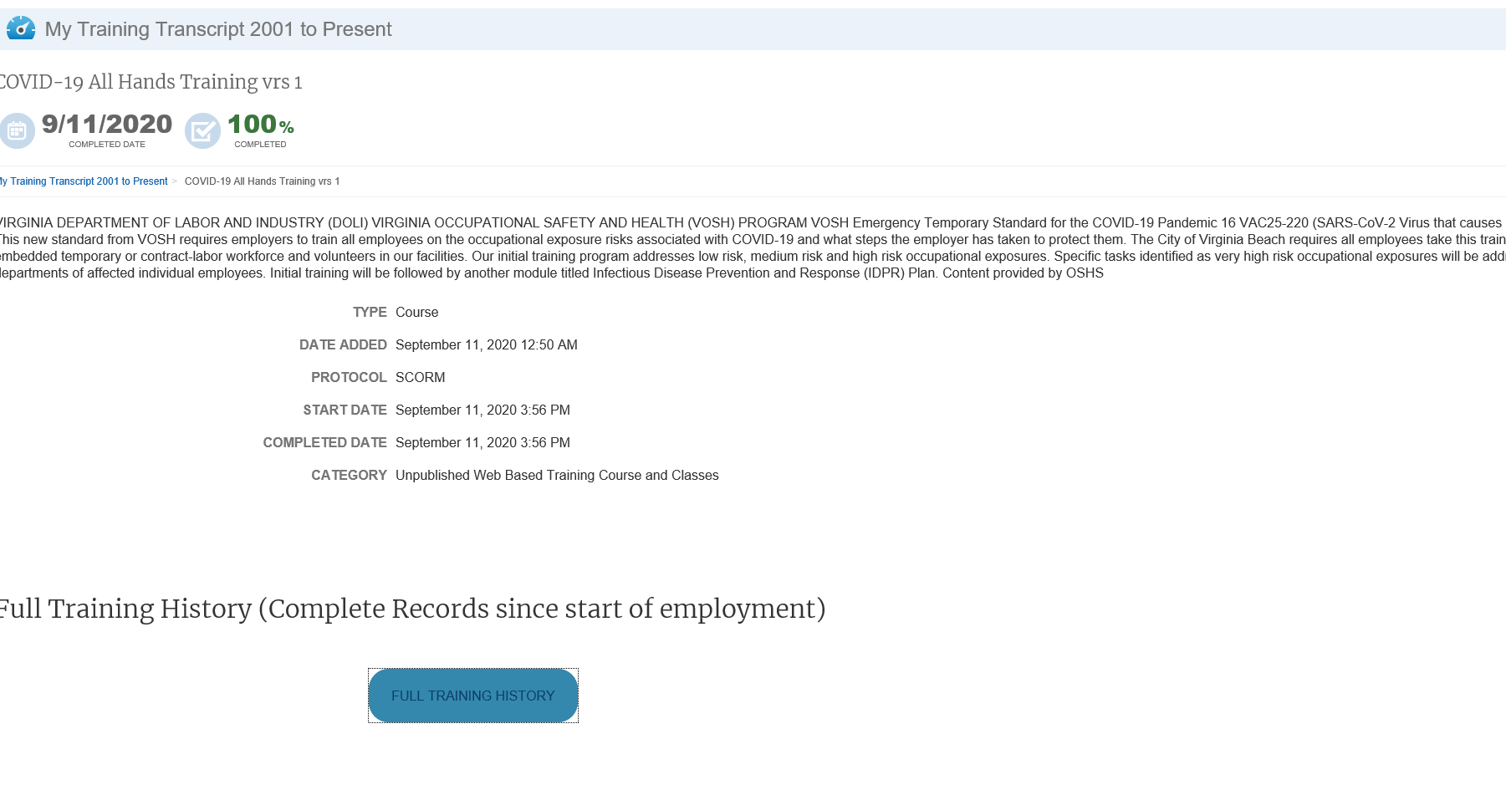

Attachment B
EXAMPLE Training Certification for Contractors, Volunteers and others who work at City facilities or worksites and cannot access Taleo directly
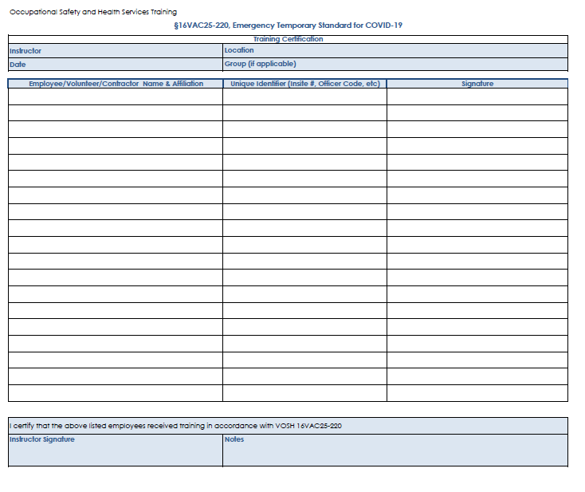
Attachment C
EXAMPLE Positive COVID-19 Test Reporting
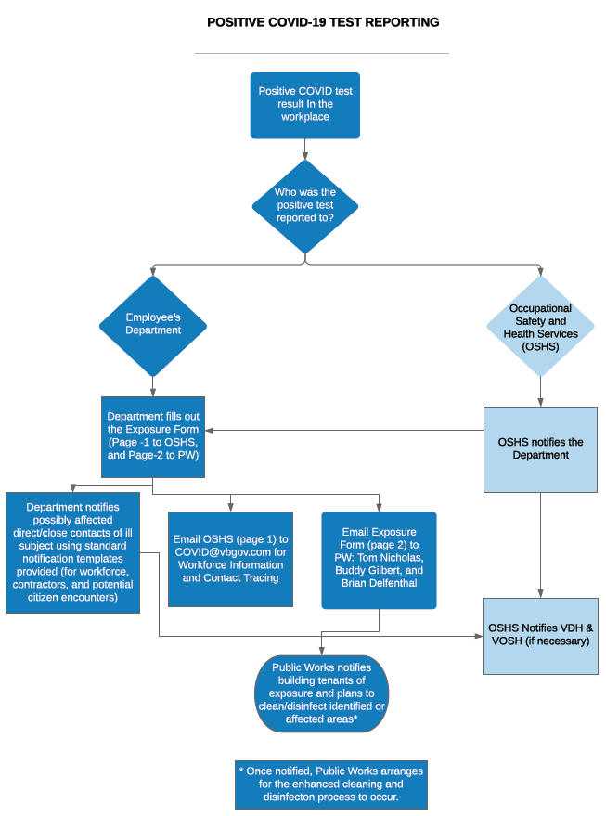
Refer to COVID-19 Information for current version

Attachment D
Updated
EXAMPLE Positive COVID-19 Notification Document –Page 1
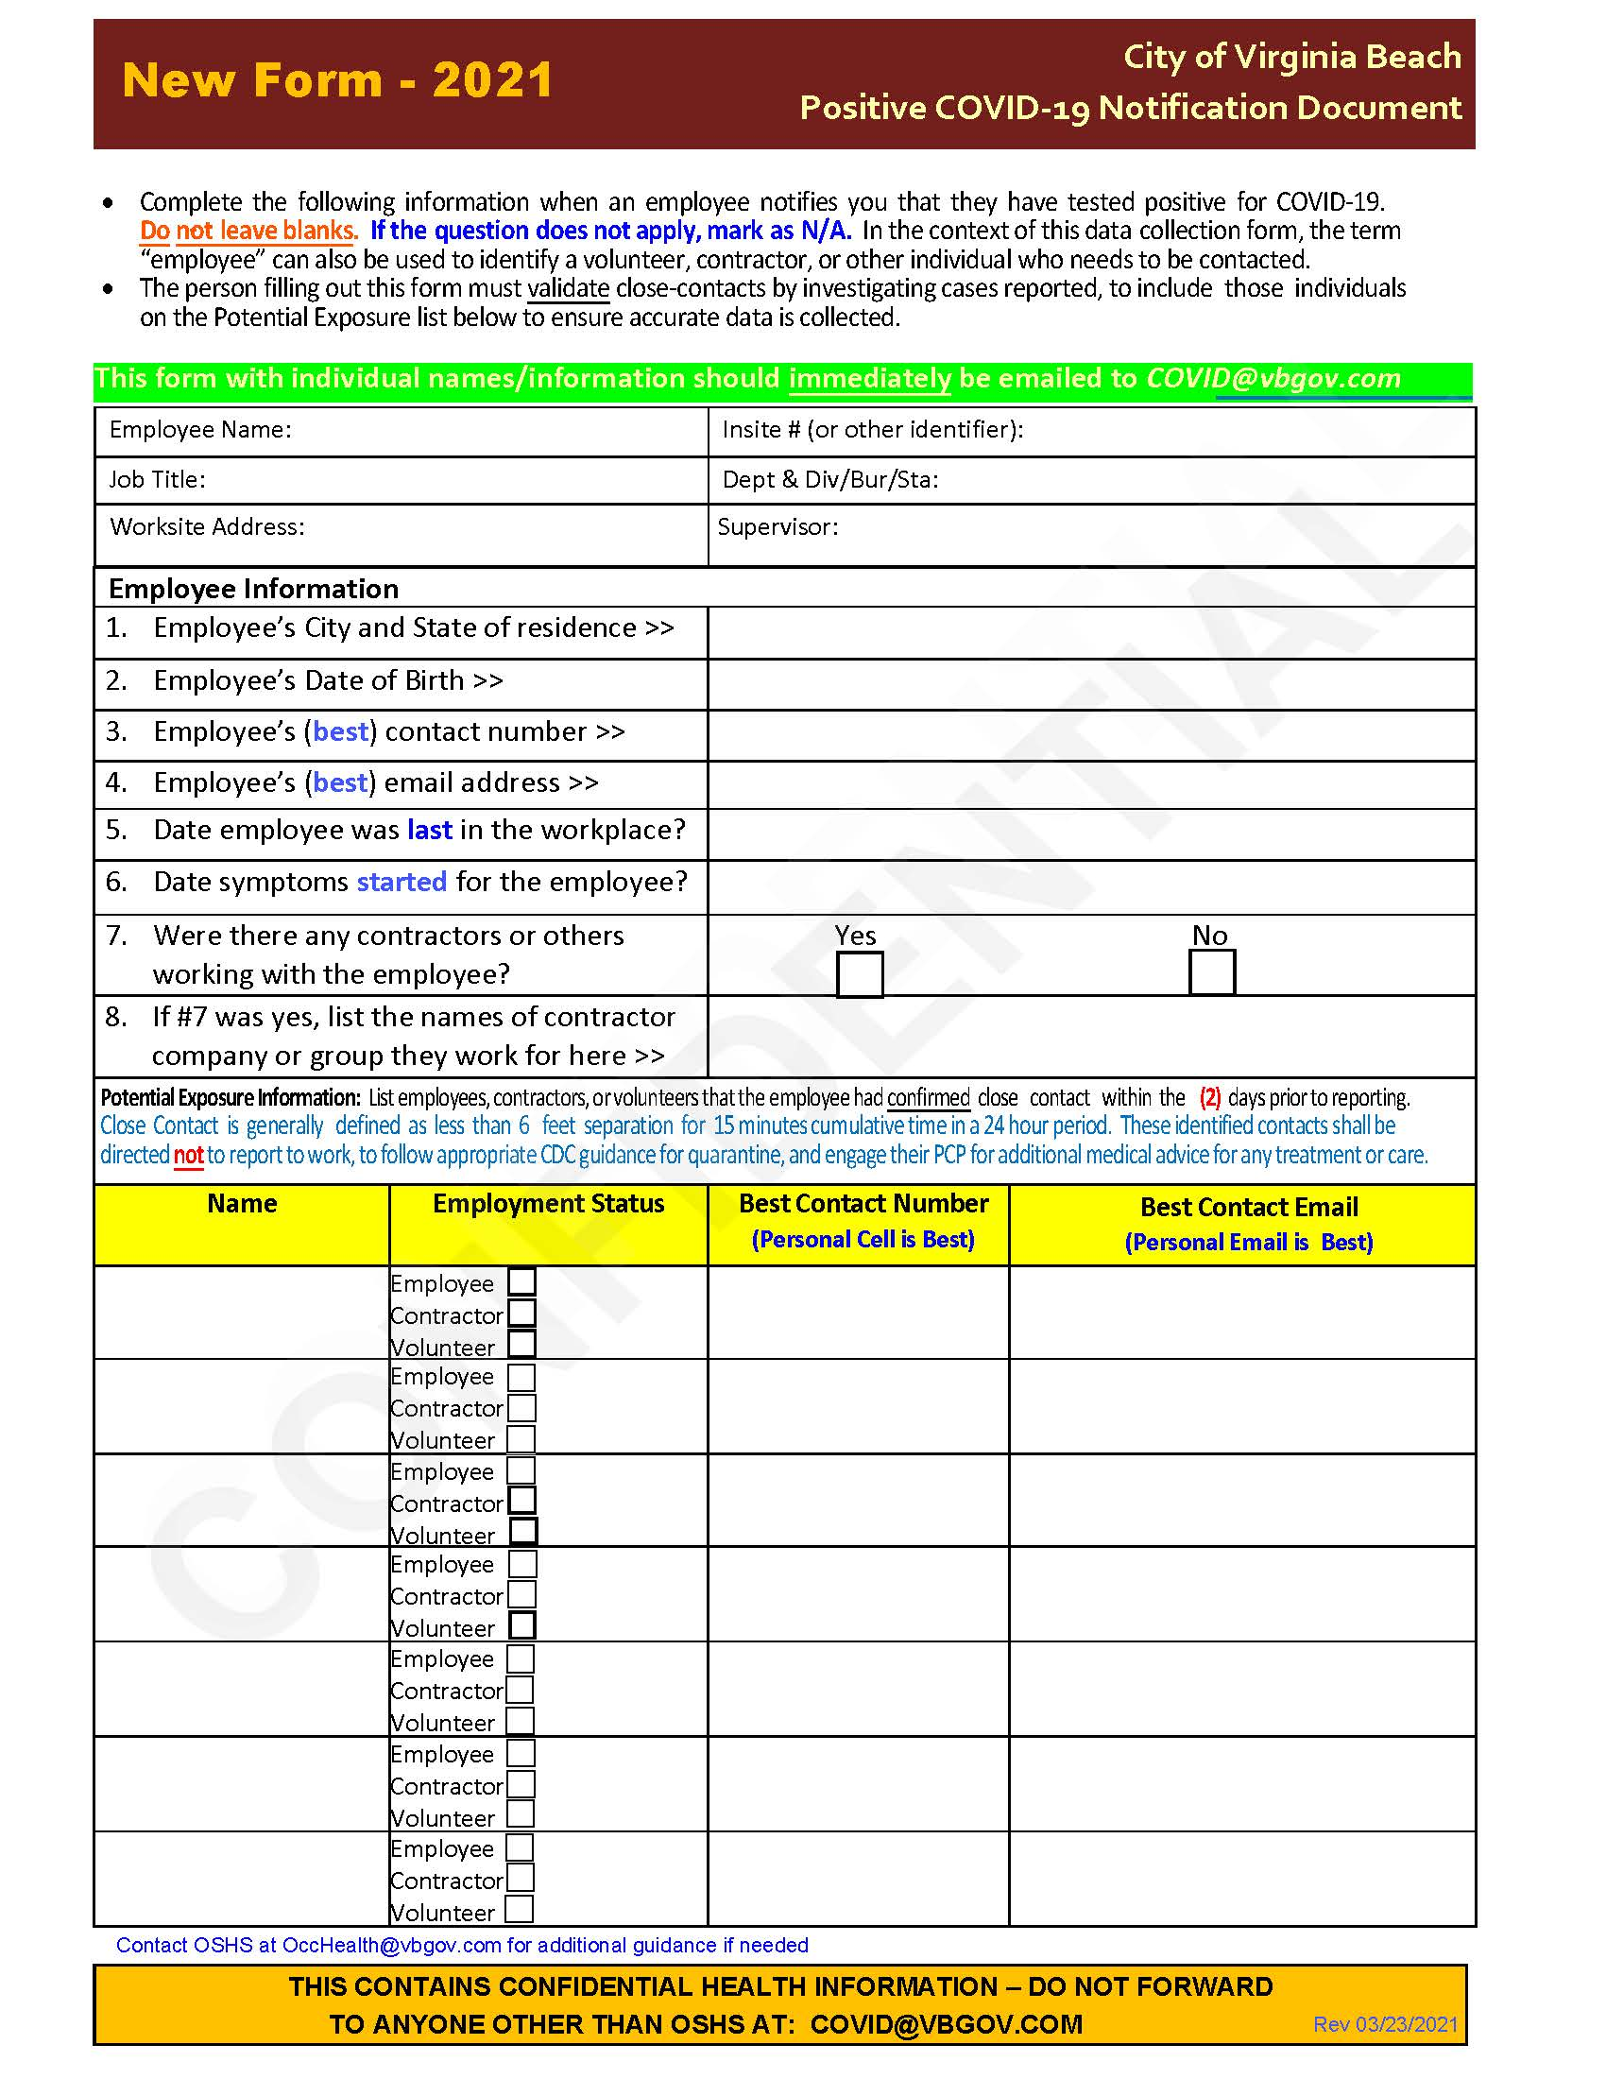
Refer to COVID-19 Information for current version

Attachment E
EXAMPLE Positive COVID-19 Notification Document –Page 2
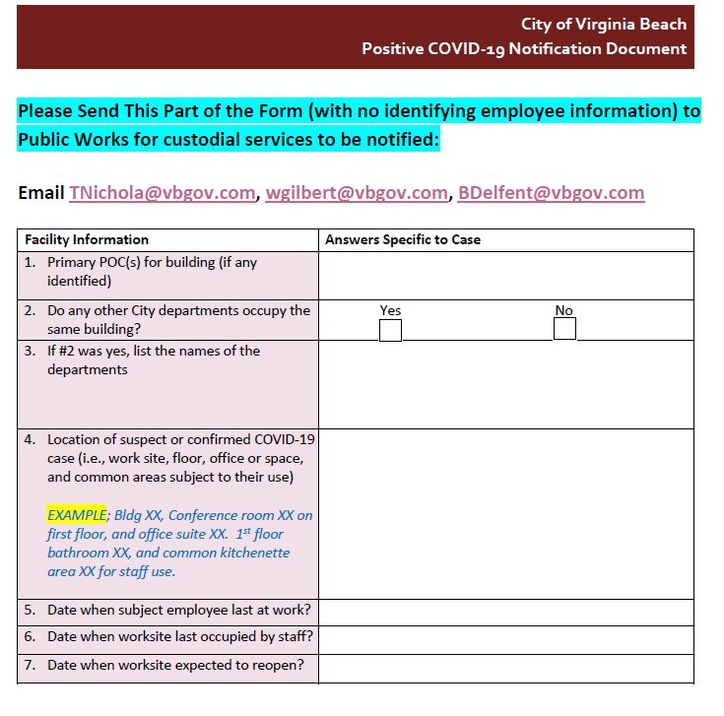
Refer to COVID-19 Information for current version

Annex A
EXAMPLE Hazard Assessment Form (Local departmental use – to provide to OSHS)
Refer to OSHS COVID-19 Guidance for current version
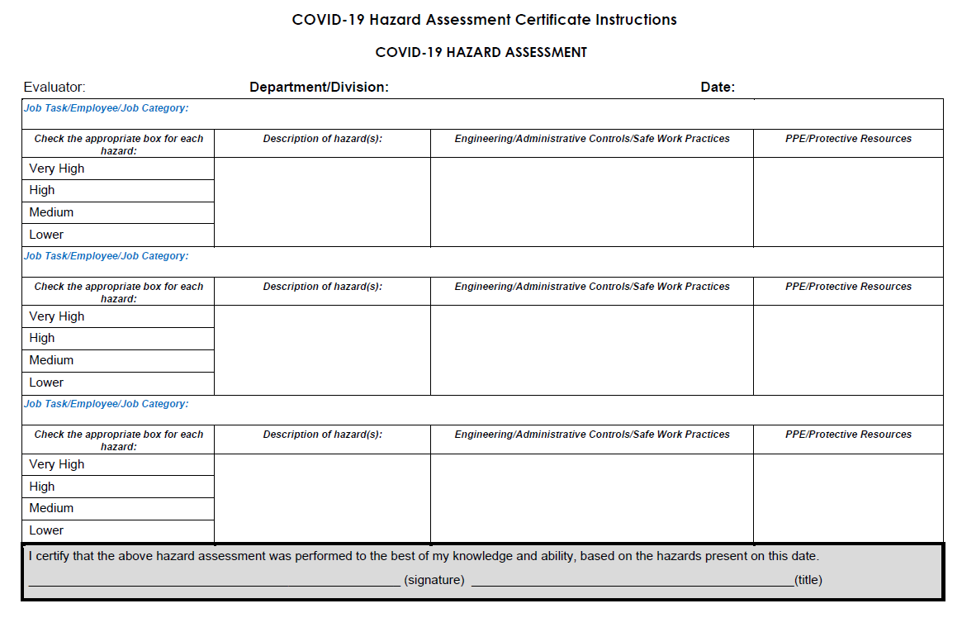
Annex B
EXAMPLE Work Hazard Assessment and Exposure Risk Level Assignment
Refer to OSHS COVID-19 Guidance for current (complete) version

